**4.UML DIAGRAM FOR FOOD ORDERING SYSTEM**

**1.CLASS DIAGRAM**

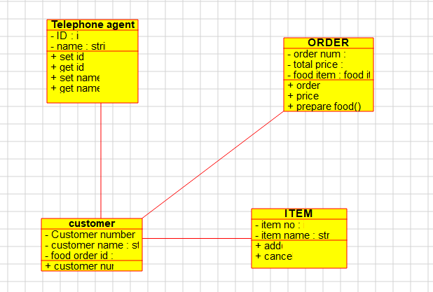

**2.USECASE DIAGRAM**

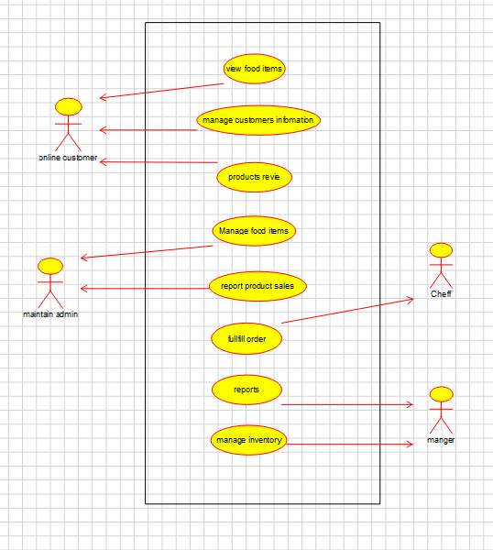

**3.SEQUENCE DIAGRAM**

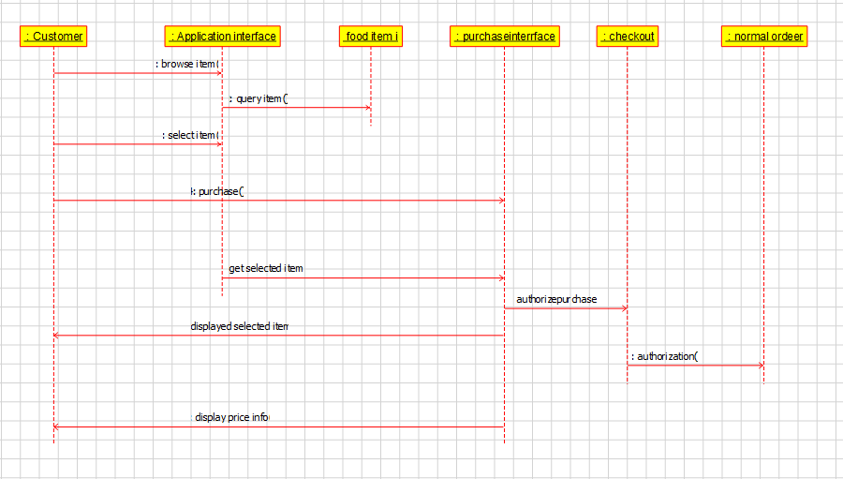

**4.STATE DIAGRAM**

